A comic book fan recently decided to open a store either in Wisconsin or Northern Illinois. They believe that one of the three major cities (Milwaukee, Madison, or Chicago) would be the best overall city. With the recent popularity of superhero and comic book movies and TV shows, the fan wants to determine if they can choose a location that is near movie theaters but far enough away from other comic book shops.

**Methodology**

The data used to solve this problem would be business location data found on Foursquare and map data from Folium. We need to consider three variables: the number of shops, the number of movie theaters, how far the current comic book shops are from the movie theaters, and if there is a theater nearby.

**Results and Discussion**

The data analysis would begin by locating all of the comic book shops in the three major cities. Using the Foursquare API, I clustered and located all of the shops. First, using the ID for comic book shops in the API, we determined that the:

* Total number of comic stores in Chicago, IL = 18
* Total number of comic stores in Milwaukee, WI = 4
* Total number of comic stores in Madison, WI = 4

I created maps of the shops to be able to visualize where they are all located.

Next, I located all of the movie theaters using the same fundamental logic. We determined that the:

* Total number of movie theaters in Chicago, IL = 85
* Total number of movie theaters in Milwaukee, WI = 10
* Total number of movie theaters in Madison, WI = 17

One flaw in the data is that Chicago and Milwaukee have much larger suburban areas which the city data does not capture. However, for purposes of this project, we will assume that the city limits are good enough.

At this point, I calculated the mean distance of the comic book shops from the mean movie theater location. Using Numpy, I calculated the mean for each of the three cities. The Mean Distance of Comics Shops from the Mean coordinates for movie theaters for each city is:

**Chicago, IL** 0.09545175878276443

**Milwaukee, WI** 0.04999490929035806

**Madison, WI** 0.06281748553155962

Below is an example of the graph comparing the mean location of a movie theater compared to the comic book stores in the city.

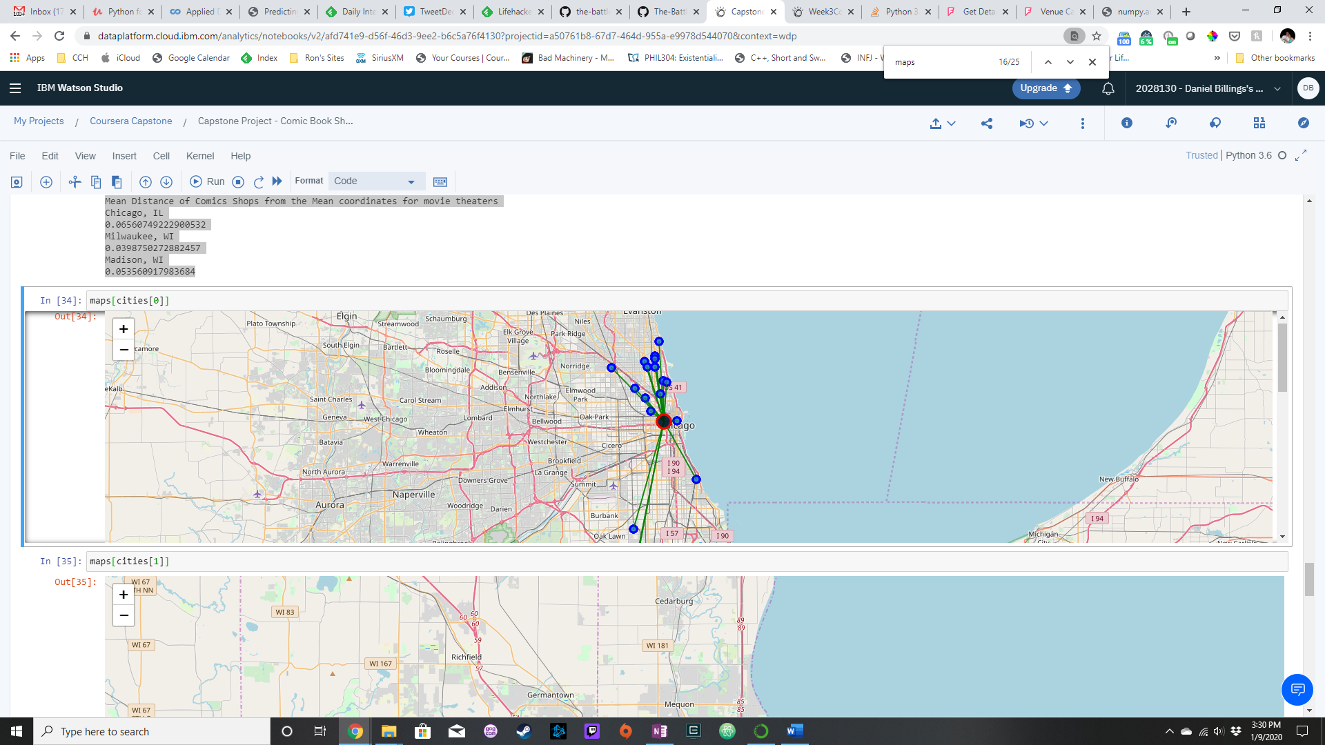

Since the owners want to have a bit of distance if they locate at the median from the closest shop, we also want to know the distance to the closest shop. Using Numpy and determining the minimum, we discover that the closest comic book shops is

* For Chicago, 0.02614300688037464 away.
* For Milwaukee, 0.03183524650700028 away.
* For Madison, 0.02611399863260902 away.

We have less competition in Milwaukee with other shops closest to the mean coordinate for the movie theaters in the city, but we have the most space to grow with the closest shop 0.038 away from the mean.

In conclusion, we should consider Milwaukee over Madison and Chicago if we want to start a comic book store near the local movies theaters with the best potential for growth and the least amount of competition.